Date:
To
The Head of Human Resource Division
Abul Khair Group
Navana F/S Kosmo, House No 4/B
Road-94, 3rd Floor, Ghulshan-2
Dhaka-1212

Subject: Application for the post of Sub Assistant Engineer (Operation)

Dear Sir,
In response of your recent advertisement in “Dainik Azadi” on 12 May 2021 asking application for the post of ‘Sub Assistant Engineer (Operation)’ attracted my attention. I would like to offer myself as a candidate for the same. My curriculum vitae are enclosed here with for your kind consideration.

I would be grateful to you if you kind enough to call me to an interview and hereby give me a chance to be a part of your organization and contribute my best as well.

Sincerely Yours

……………………
Md. Manik Hossen
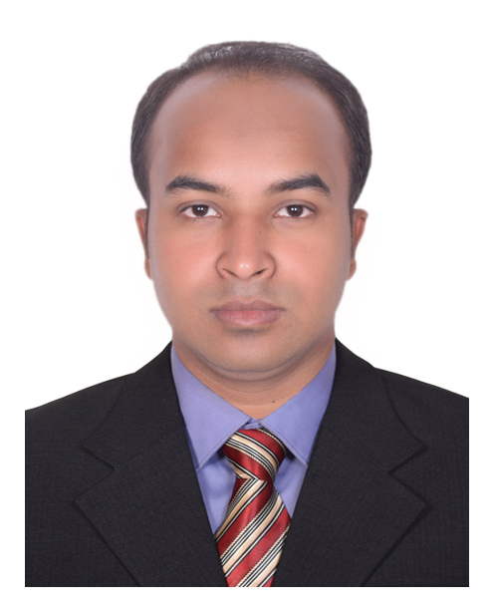
CURRICULUM VITAE OF

Md. Manik Hossen
East Mohammad Pur, Boyar Char
Hatia, Nowakhali, Bangladesh.
Mobile No: +8801843230441
Email: cpimanik94@gmail.com

Career Objective:

I would like to work challenging, hardworking and competitive job for self evaluation as I know myself. I do believe that I will make significant contribution with my ability and hard working capacity.
Education Qualification:
Diploma in Engineering
Institute : Chittagong Polytechnic Institute
Nasirabad, Chittagong
Department : Power Technology
Result : GPA- 2.99 (In a scale of 4.0)
Passing year : 2017
Board : Bangladesh Technical Education Board. Dhaka

Secondary School Certificate (S.S.C) Vocational
Institute : Technical Training Centre.
Nasirabad, Chittagong
Department : General Electronics
Result : GPA- 4.77 (In a scale of 5.0)
Passing Year : 2012
Board : Bangladesh Technical Education Board. Dhaka

Job Experience:
Currently service in N.M. HONDA CENTER As a Service Advisor from 21st January 2018. 163 Sultan Chamber, SK. Mujib Road, Agrabad, Chittagong.
Industrial Attachment
- Industry Name : Pragoti Industries Limited
Barabkunda, Sitakund Chittagong
Duration : 03 (Three) Months

- Industry Name : Bangladesh Industrial Technical Assistance Centre (BITAC)
Sagorika Road, Pahartali Chittagong
Duration : 06 (Six) Weeks
Basic Course
Course Name : Auto Mechanics
Institute Name : UCEP A.K Khan Technical school
Kalurghat, Chittagong
Duration : 06 (Six) Months

Computer Skill:
- MS office application (Microsoft Word, Excel, Power point).
- Email And Internet Browsing

Personal Details:

Father's Name : Md. Sahab Uddin
Mother's Name : Parvin Begum
Date of Birth : 1st Nov 1994
Sex : Male
Blood Group : B (+) Positive
Marital Status : Married
Religion : Islam
Nationality : Bangladeshi (By Birth)
National ID : 4168680496

Personal Strengths:

- Able to work and stay focused under pressure
- To work in a group under guidance and able to guide others
- Excellent skills in communication
- Reading Various Interesting Books
- Traveling And Visiting Attractive Place And Try To Learn Something

Reference:

Pradip Kumar Talukdar  Chief Instructor & Head of Department.  Department of Power Technology  Chittagong Polytechnic Institute  Mobile No : 01818823736 | Md. Mine Uddin  Jr. Instructor  Department of Power Technology  Chittagong Polytechnic Institute  Mobile no: 01710202405
Certification:

I the undersigned declared that the above information is correct and true.

Signature:
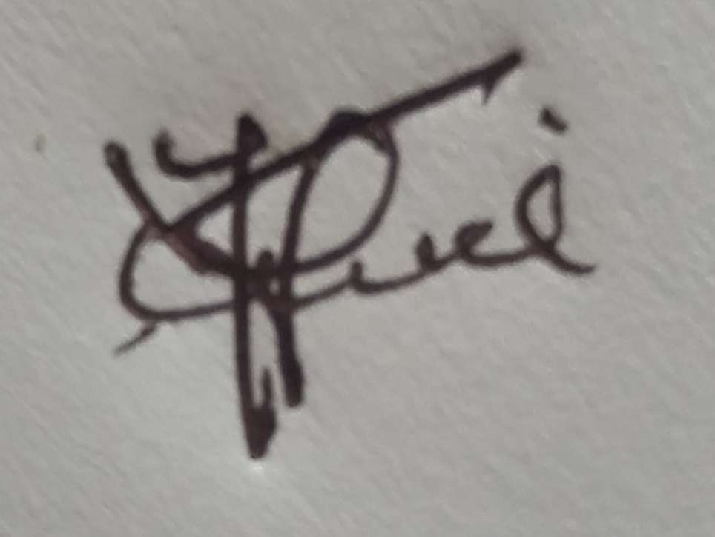

Md. Manik Hossen

